**Github link: https://github.com/sasidharpulukuri/databasepart3**

**ERD Model PART 3**

Illustrate that you understand normalization and how to use it to reduce uncontrolled redundancy in your database design by creating two ERD diagrams:

**Answer:** The normalization belongs with the customer details, order details, order status, payment and review. There are two sections in the normalization. One is customer details, order details and order status and another is payment and review.

Create the first using UML and the Umlet free utility.

**Answer:**

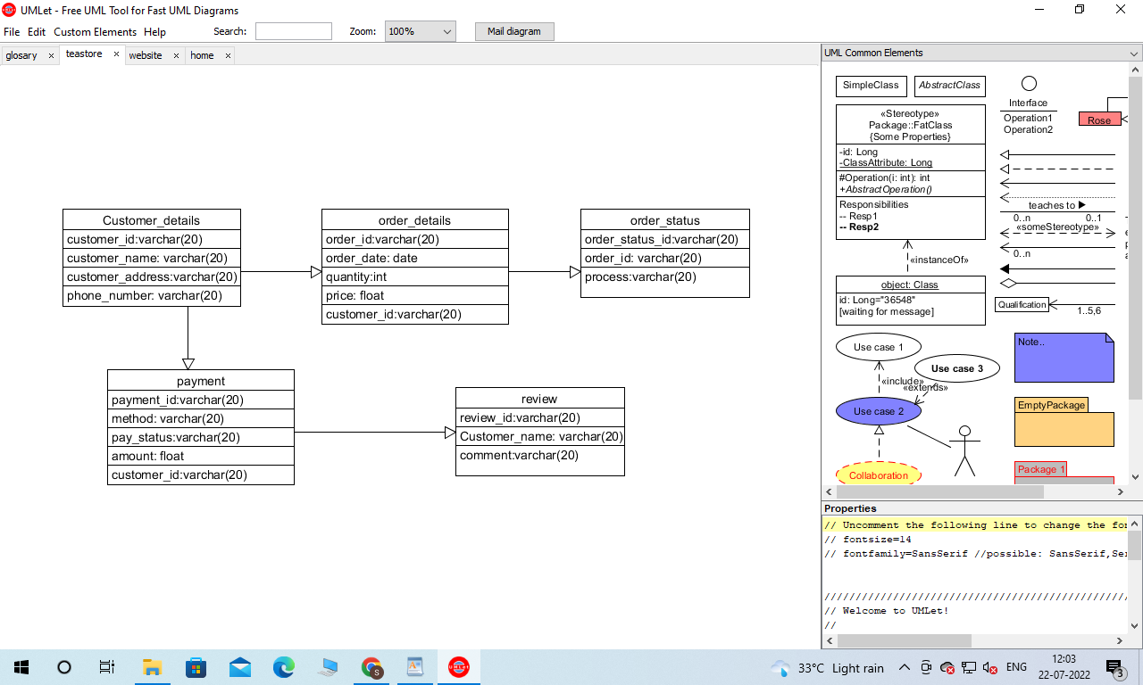

Create the second using Crow’s Foot notation in Vertabelo.

**Answer:**

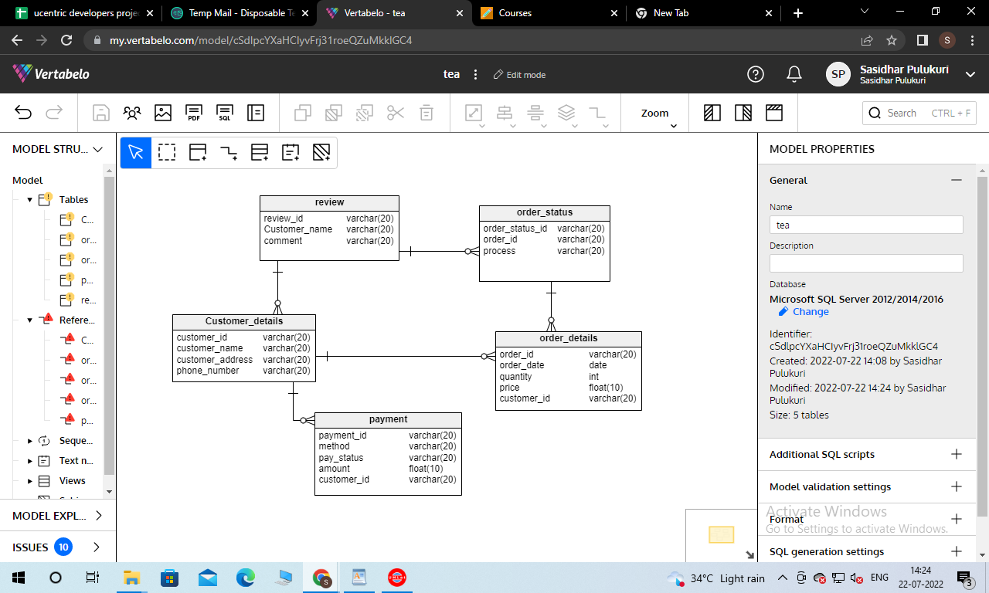

**Changes:**

**Relationship Describtion:**

In the above figure, using Crow’s Foot notation the ERD model is shown. The normalization belongs to review, order status, customer details, order details and payment. The primary key is the customer id of the customer detail table and foreign key is the customer id of the order detail table. In order status table order id is the foreign key of order details table. In the payment table, payment id is the primary key and customer id is the foreign table of the customer detail table. In the review table, the primary key is review id. The arrows between the tables are denoting the relationship between the tables.